**USING RAPTOR – DISPLAY POSITION OF NUMBERS**

**ANIRUDH.R(192011013)**

**FLOWCHART**

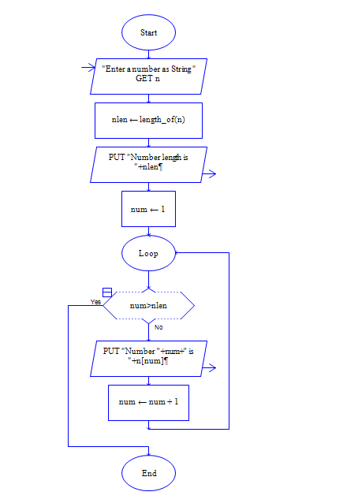

**OUTPUT**

INPUT IS VISHNU079

